Web Design

CSCI: 3950

Final Project



Rob Manning

Nicholas Morelli

Michael Tan

The A Team ©

**PupFetcher Website**

**\* * \***

**Client’s Request and Requirements:**

Our client has requested a website to sell puppies. “You will be able to search for just about any puppy you can think of.”

* Website has to be visually appealing and enjoyable.
* Targeting animal lover’s clients. Therefore the website needs to be user friendly with a charming design.
* When entering the website, the user has to arrive on a page asking whether to search for a puppy or browse the database for one.
* Search will bring up specific information from the database.
* Browse function will go through the entire database.
* All the classic functions of an E-commerce website.
* No international business intended but the shipping can be completed in the entire USA

**Team Presentation**

**Responsibilities:**

As a group we focused on every area of the project. We truly believe that it is a great asset have more that one pair of eyes on every part of the website. Moreover, it helps to keep the amount of errors to a minimum during a development of the project. However, we divided up the work with each group member in order to have a main area to focus on.

- Michael’s main responsibility was to take care of the whole design aspect. Nevertheless, the advancement of the project also lead him to help out with the other parts, such as PHP, SQL, and setting up the database.

- Rob and Nick both shared the responsibilities of creating the PHP, SQL, and database design. They also helped out with the CSS when a modification was needed.

**Task distribution:**

Bellow is a table detailing the role of each team member on the different pages of the website.

|  |  |  |  |  |  |
| --- | --- | --- | --- | --- | --- |
| Pages | HTML | CSS | PHP | SQL | JAVASCRIPT |
| Index.php | Michael | Michael |  |  | Michael |
| Puppies.php | Nicholas  Michael | Michael | Nicholas | Nicholas |  |
| Info.php | Michael | Michael |  |  |  |
| pupInfo.php | Michael | Michael | Nicholas | Nicholas |  |
| Sidebar.php | Michael | Michael | Nicholas  Michael | Nicholas | Michael |
| Login.php | Rob  Michael | Michael | Rob | Rob | Michael |
| Register.php | Rob  Michael | Michael | Rob  Michael | Rob |  |
| loginProcess.php | Rob |  | Rob | Rob |  |
| Pupcart.php | Nicholas  Michael | Michael | Nicholas | Nicholas | Nicholas |
| Checkout.php | Michael | Michael | Rob | Rob |  |
| Confirm.php | Michael | Michael | Michael |  |  |
| Search.php | Nicholas |  | Nicholas | Nicholas |  |
| Database.php |  |  | Nicholas | Nicholas |  |
| addToCart.php |  |  | Nicholas |  | Nicholas |

**Test methods:**

The testing phase was accomplished following two definite procedures, Black box and walkthrough testing. Every single webpages and functions were examined during a Black box testing, which consisted of acting like a real user and do many run-throughs a web page in order to find any problems. Afterward, even when an error was not found we continued with a walkthrough test, which is a procedure made to verify the codes or automatic scripts of the webpage.

Since the test phase is an important part of a website development, each webpages have been individually tested several times by all three team members.

**Website Presentation**

**Design:**

The design of a website is a certainly one of its most important part. Without a proper interface a user can easily get bored annoyed and leave the website without even paying attention to its content or features. Thus, losing a possible client.

In order to get the inspiration for a suitable design theme that fits the layout of the future home page, Michael visited many dog selling websites and gathered the good ideas to incorporate to the website layout.

He later drew on Photoshop the first sketch of what he had in mind for the design of the home page. After experimenting with some other ideas, Michael determined and designed the layout of the home page on Dreamweaver.

**Theme design composition:**

****The background is made of a small striped PNG picture tiled horizontally and vertically. This process reduce the amount of time for the loading of the website. It also has the advantage of fitting every screen resolution. The same technic was used to make the main container with a 70% transparency PNG picture.

The sidebar and login animation was accomplished thanks to a online tutorial called “smooth scrolling div”, the script necessary is coded in javascript, HTML and CSS.

Michael finally used a Lynda.com tutorial to create a moving slideshow of multiple puppy pictures. The slideshow is coded in Javascript as well.

**PHP Features:**

**Search function:**

The search sidebar makes it easy for the user to search our database for the perfect puppy. The user can choose between a specific search method or a more generalized one. The specific search uses the breed, gender, and age as the search requirements, while the others are just preferences. The generalized search queries the database specifically for the size of dog, while the upkeep and location are preferences as well. If the user does not enter all of the required fields, it sends the user to the puppies page that displays every puppy in the database. All of the breeds and sizes of puppies are pulled straight from the database and put in a drop-down menu so that the user does not aimlessly search for a puppy that we do not have.

**Login function:**

The login feature was essential to the website because without logging you are not able to purchase a puppy. When logging in you are able to view the checkout page successfully and buy as many puppies as requested. When the user logs in, the login button changes to logout, verifying that the website knows there is a user in session. Upon logging out, the login button shows back with its drop down menu enabled. The login includes several files for security and verification of proper user information.

**Register function:**

You cannot purchase a puppy without registering an account first. Registering is vital to the website because without registering people cannot purchase puppies and there is no business. You are required to register before checking out. When one registers, personal information along with shipping information from the user is taken to complete checkout with ease. Input validation is used in almost every field to verify correct information is entered. One of the most powerful parts of the checkout, is the credit card actually requires a legit credit card, not just a sixteen digit number. Upon registering the user is able to login and purchase a puppy.

**Cart function:**

If the cart is empty and the user attempts to navigate to the cart, an error will pop up telling them that the cart is empty and will redirect them to the puppies page, which displays all of the puppies we have in the database. When the user adds a puppy to the cart, the puppy_id is stored in the user’s session. When the cart is displayed, it takes the ids from the session, queries the database, and displays all of the puppies in the cart. If the user tries to add a puppy to the cart that they have already added, they will receive an error message telling them that the puppy is already in their cart. A quantity field in the cart is unnecessary because no two puppies are the same. The user cannot buy two of the same puppy. The user can also choose to remove an item from his cart by clicking the remove button, which sends to remove.php and takes the puppy_id out of the session.

**User Manual**

**Home page:** This page introduce the website and the PupFetcher company and what is their business about. The user can easily access to the different pages of the site thanks to its large navigation bar.

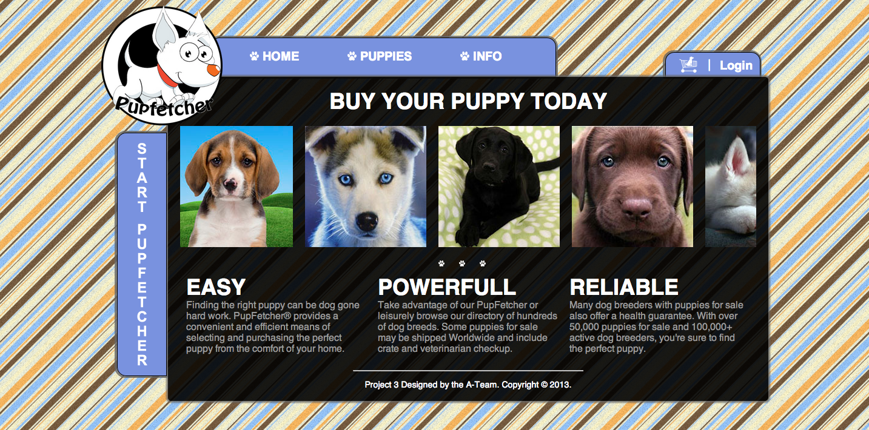

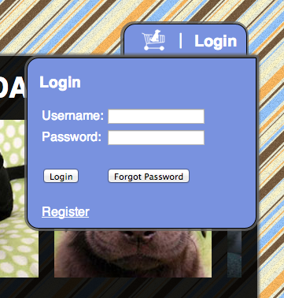

**Login:** The login button is always displayed so the user can connect at all time.

The unrolling menu also gives the option to register if the user is not already in the database.

**Browse a puppy:** This page can be accessed by clicking on link “Puppies” in the navigation bar. This page gives the opportunity to browse every puppy of the database. The user will have the option to click on “View profile” to get more info about a puppy or to click on “add to cart” to start an order.

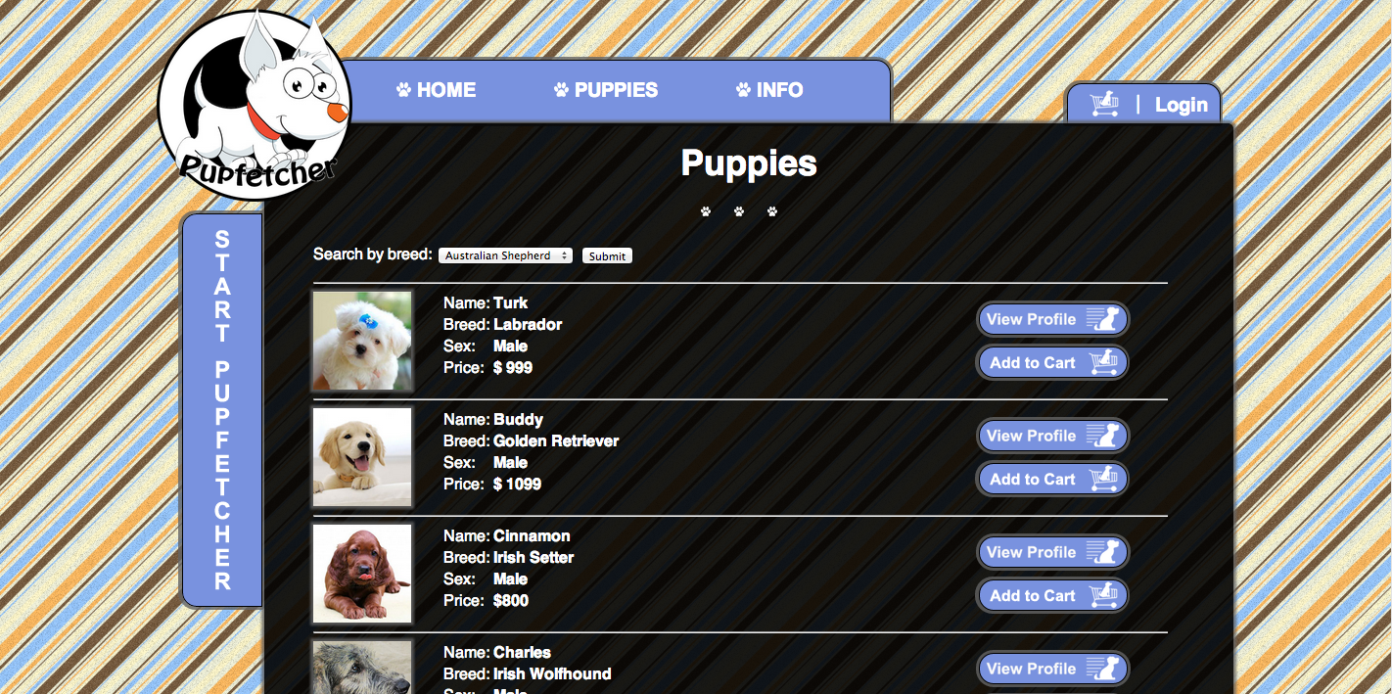

**Search tool bar:** The user also has the possibility to look for a specific puppy thanks to the PupFetcher tool bar located on the left.

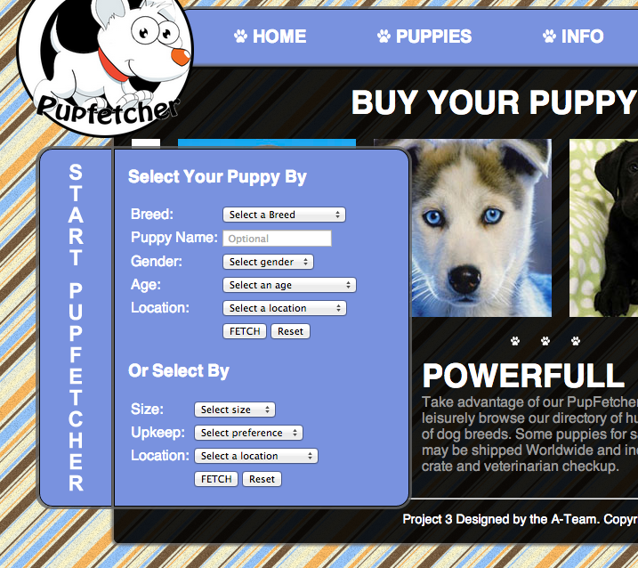

**PupInfo:** This page can be accessed by clicking on link “View Profile”. This page gives all the info about a puppy. It also allows the user to add the puppy to the pupCart.

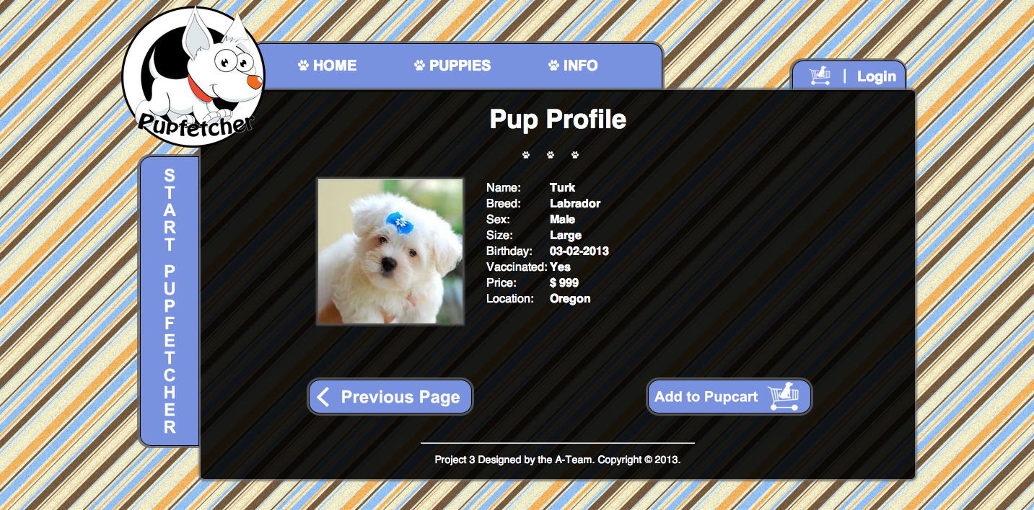

**PupCart:** This page can be accessed by clicking on link “add to pupcartor by clicking the cart logo next to the login. This page will display the puppy the users selected and allow them to proceed to check out.

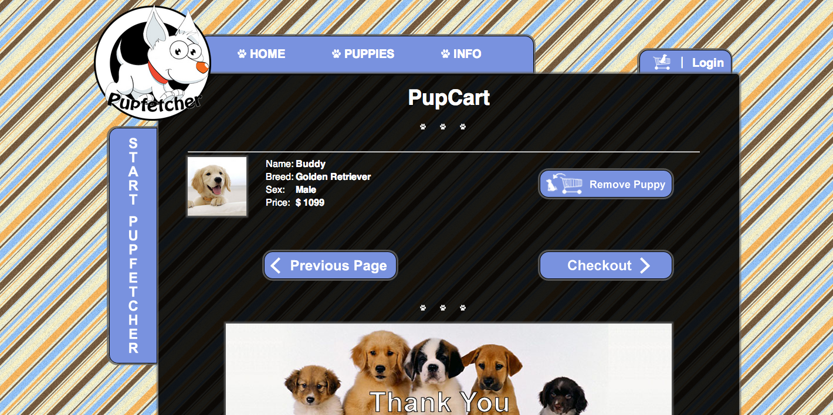

**Checkout:** This page summarize the puppy the user selected and display you shipping address before the user click on place order.

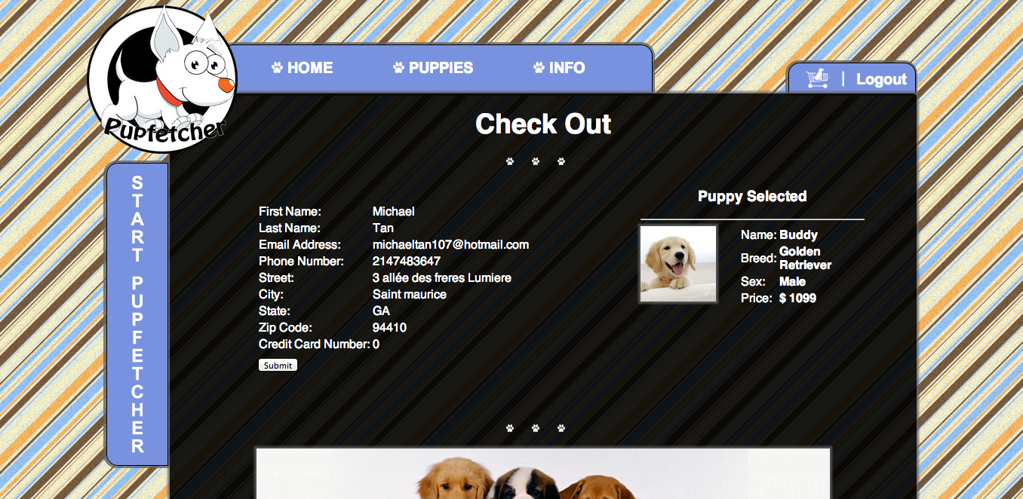

**Place Order:** This page thanks the user and gives information about when the order is supposed to arrive.